Homework: Empirical Rule and Z-score

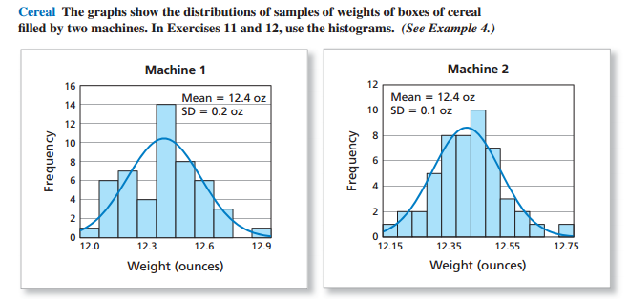
1) The graphs above are from MathAndYou.com Section 9.3 (page 431). In the graphs above, explain the real-world, practical significance of the fact that the standard deviation of Machine 1 is greater than the standard deviation of Machine 2.

2) The graphs above are from MathAndYou.com Section 9.3 (page 431). In the graphs above, use the Empirical Rule to estimate the percent of boxes that would weigh at least 12.2 ounces for each Machine. Show your work/explain how you arrived at your answer.
Solution
Machine I
P (w >12.2)
Mean (µ) = 12.4
SD = 0.2
= p [(x - µ)/σ > (12.2 – 12.4)/0.2]
= p (z > -1)
= 1- p (z ≤ -1) = 1 – 0.1587 = 0.8413

Machine 2
P (w >12.2)
Mean (µ) = 12.4
SD = 0.1
= p [(x - µ)/σ > (12.2 – 12.4)/0.1]
= p (z > -2)
= 1- p (z ≤ -2) = 1 – 0.0228 = 0.9772

3) Lengths of pregnancies are normally distributed with a mean of 268 days (which is about 9 months) and a standard deviation of 15 days.
  - Sketch the normal curve, and label everything appropriately using the Empirical Rule, z-scores, and data values with the appropriate pregnancy lengths.
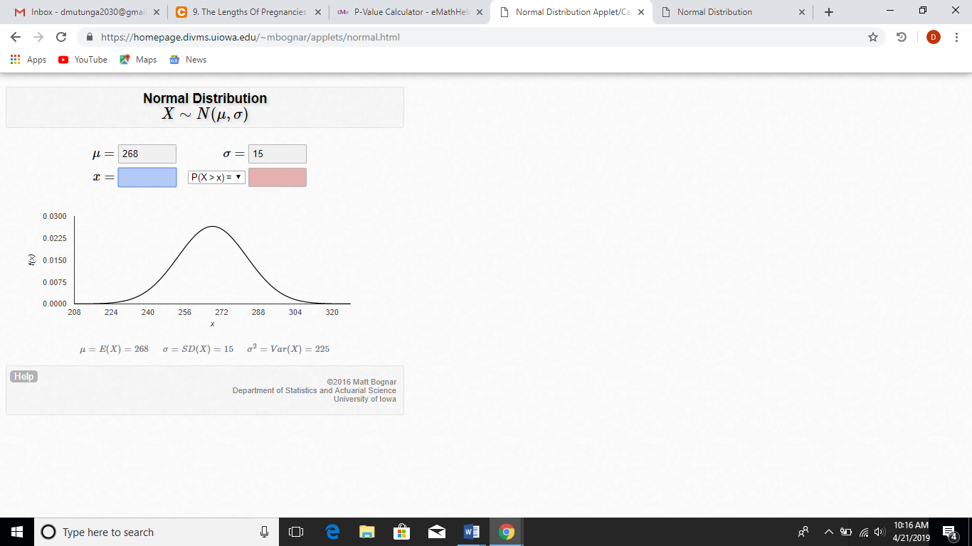
  - What percent of women have a pregnancy that lasts less than 253 days?
Solution
P (w < 253)
Mean (µ) = 268
SD = 15
= p [(x - µ)/σ < (253 – 268)/15]
= p (z < -1) = 0.1587
= 15.87%
  - What percent of women have a pregnancy that lasts less than 238 days?
Solution
P (w < 238)
Mean (µ) = 268
SD = 15
= p [(x - µ)/σ < (238 – 268)/15]
= p (z < -2) = 0.0228
= 2.28%

  - What percent of women have a pregnancy that lasts more 313 days?

P (w >313)
Mean (µ) = 268
SD = 15
= p [(x - µ)/σ > (313 – 268)/15]
= p (z > 3)
= 1- p (z ≤ 3) = 1 – 0.9987 = 0.0013

4) Stanford Binet IQ scores have a mean of 100 and a standard deviation of 16. IQ scores are roughly normally distributed.
- Sketch the normal curve, and label everything appropriately using the Empirical Rule, z-scores, and data values with the appropriate IQ scores.

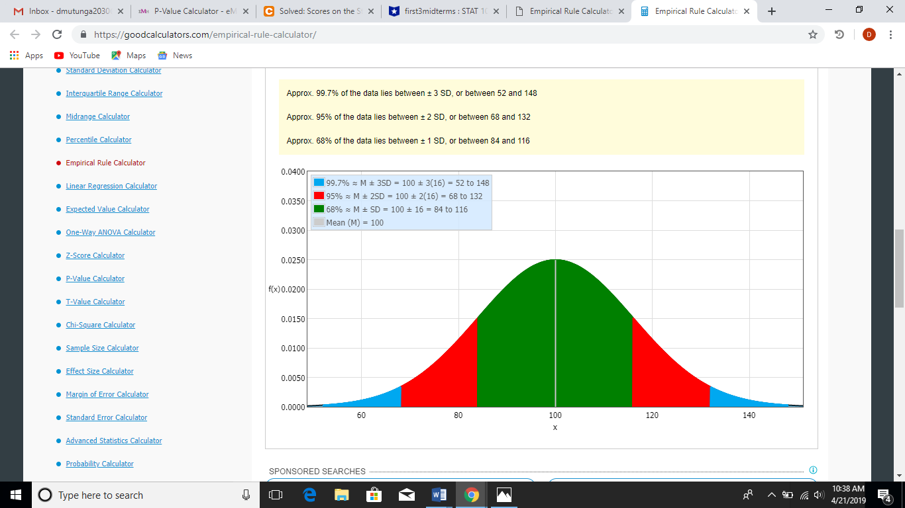

- If a person's IQ has a z-score of −0.3, then explain what that tells you about how the person's IQ
compares to other people's IQ.

- A person has an IQ of 82. Find the z-score for this IQ score, and explain exactly what it tells you about how this person's IQ compares to other people.
- To have an "unusually high" IQ, a person would need to have an IQ with a z-score of 2 or more. How high would a person's IQ need to be to be considered "unusually high?" Show your work.
- Albert Einstein had an estimate IQ of 160. Convert Einstein’s IQ score to a z-score (show your work). What does the z-score tell us about Albert Einstein’s IQ? Is it unusual?

